Batho Ba Rona Supermarket — Network Design Documentation
CMPG 325 — Computer Networks | Project ID: CMPG325-2026-015 | Client ID: CLI-015

This document presents the network design for Batho Ba Rona Supermarket (Mahikeng), a retail client assigned under Project ID CMPG325-2026-015. The project covers the client's requirements, the physical and logical topology, the IP addressing plan, and the assigned Default Routing (edge/ISP path design) challenge, culminating in a working Cisco Packet Tracer implementation.

Client Background
Batho Ba Rona Supermarket is a retail supermarket located in Mahikeng, serving the local community with everyday grocery and household goods. As a small business, it operates with limited in-house IT capacity, relying on a single part-time IT support person to manage all technology needs. The store's daily operations depend on point-of-sale (POS) systems for customer transactions, administrative staff for stock and business management, and wireless connectivity for staff use. The client requires a reliable, easy-to-maintain network that supports these functions while remaining simple enough for one person to manage.

- Client Requirements (from brief):
- Assigned addressing block: 192.168.17.0/24
- Provide appropriate connectivity and network services for the retail scenario
- Design manageable by one part-time IT support person
- Demonstrate configured, verified Default Routing (edge/ISP path design)
- CR5: user numbers grow by 25% — addressing plan must absorb this without renumbering
Derived Requirements (based on analysis):
- Segment traffic logically by department: Point-of-Sale, Administration, Wi-Fi/Staff, and a Server segment for inventory/stock systems
- Since exact device counts were not specified, realistic estimates for a small retail supermarket were used as the basis for subnet sizing.
- Keep the routing design simple (static default route) to match the one-person IT support constraint.
- PHYSICAL TOPOLOGY
The physical topology below shows the devices and cabling implemented for Batho Ba Rona Supermarket in Cisco Packet Tracer. It includes an ISP router, an edge router (which holds the default route), a core switch, and three access switches serving the POS, Admin, and Wi-Fi/Staff departments, along with their respective end devices.

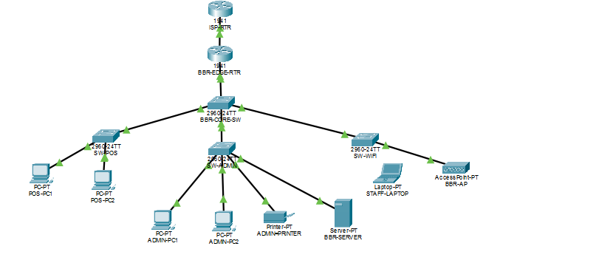
FIGURE 1: Physical topology of the Batho Ba Rona Supermarket network, showing devices and cabling.

- LOGICAL TOPOLOGY
The logical topology below shows the same network layout as FIGURE 1, annotated with VLAN assignments, subnets, and gateway IP addresses for each segment. It illustrates how the assigned 192.168.17.0/24 address block is divided across the POS, Admin, Wi-Fi/Staff, and Server VLANs, as well as the WAN link connecting the edge router to the ISP.

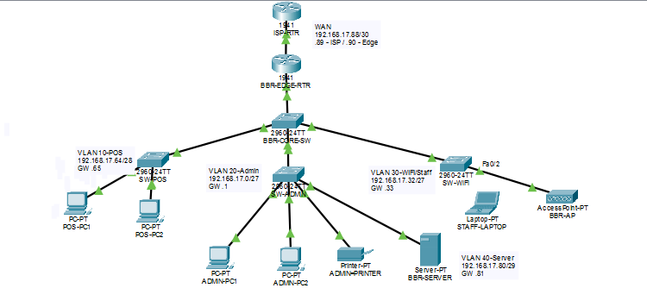

FIGURE2: Logical topology of the Batho Ba Rona Supermarket network, showing VLANs and IP addressing.

- IP ADDRESS PLANNING
The addressing plan below uses VLSM to divide the assigned 192.168.17.0/24 block. Each subnet is pre-sized to accommodate a 25% increase in users (CR5) without requiring any renumbering.

VLAN | Subnet | Subnet Mask | Usable Hosts | Host Range
20 – Admin | 192.168.17.0/27 | 255.255.255.224 | 30 | .1 – .30 (GW .1)
30 – Wi-Fi/Staff | 192.168.17.32/27 | 255.255.255.224 | 30 | .33 – .62 (GW .33)
10 – POS | 192.168.17.64/28 | 255.255.255.240 | 14 | .65 – .78 (GW .65)
40 – Server | 192.168.17.80/29 | 255.255.255.248 | 6 | .81 – .86 (GW .81)
WAN – Edge↔ISP | 192.168.17.88/30 | 255.255.255.252 | 2 | .89 – .90

4.1 GROWTH PLANNING (CR5)

VLAN | Current Devices | +25% Growth (CR5) | Planned Capacity
POS | 10 | 12.5 → 13 | 16
Admin | 15 | 18.75 → 19 | 30
Wi-Fi/Staff | 20 | 25 | 30
Server | 3 | 3.75 → 4 | 6

By sizing each subnet to the post-growth requirement from the outset, the network can absorb the CR5 change request simply by connecting new devices into existing VLANs — no re-addressing or renumbering is required. Unused address space also remains in the 192.168.17.0/24 block beyond these five subnets, providing further headroom.

- DESIGN JUSTIFICATION

With only one part-time IT support person available, the design favours simplicity: a static default route from the edge router to the ISP (rather than a dynamic routing protocol), and a small, fixed number of VLANs (four) that are easy to document and maintain.

- Default Routing Design
The edge router is configured with a static default route (0.0.0.0/0) pointing to the ISP router, so that any traffic not destined for a local subnet is forwarded out to the simulated internet. This will be configured, verified with ping/traceroute, and documented with screenshots in a later section.

